Miles Shinsato

10/27/2024

Module 1.3 Assignment

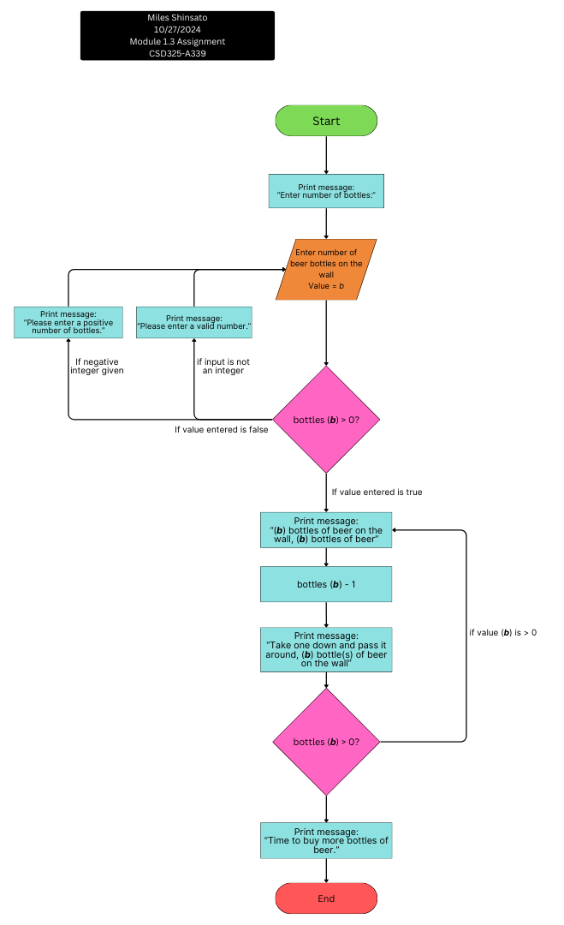CSD325-A339